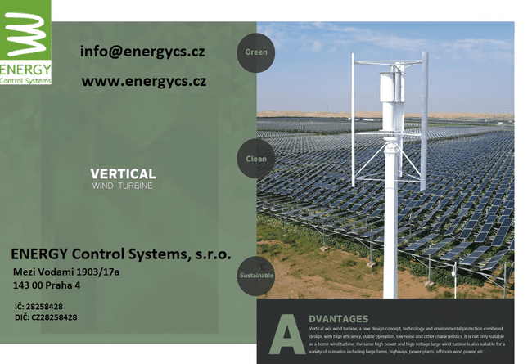

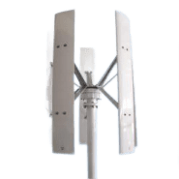

Type H12

Model | H12 -200 | H12 -300 | H12 -400 | H12 -500 | H12 -600 | H12 -800 | H12 -1000 | H12 -1500
Rated power | 200w | 300w | 400w | 500w | 600w | 800w | 1kw | 1.5kw
Rated voltage | 12V/24V/48V |  |  |  | 24v/48v/96v
Start the wind speed | 2m/s
Rated wind speed | 12m/s
Safe wind speed | ≤50m/s
Blade diameter/height（ m） | 0.75/0.8 | 0.75/1 | 0.75/1.2 | 0.75/1.4 | 0.95/1.4 | 0.95/1.6 | 1.28/1.8 | 1.28/2
Number of blades | 5
Blade material | Aluminum alloy
Fuselage material | Aluminum alloy
Magnetic steel material | NdFeB
Generator type | Three-phase AC permanent magnet synchronous generator
Control mode | Electromagnetic brakes
Wind direction adjustment | 360° automatic windward wind
Service life/Degree of protection | ≥ 20 yearsIP54
Net weight/gross weight（kg） | 15/17 | 16/18 | 17/19 | 18/20 | 21/23 | 23/25 | 75/90 | 85/100
Packing size（ cm） | 35*34*22+  85*26*26 | 35*34*22+  110*26*26 | 35*34*22+  130*26*26 | 19*19*21+  147*26*26 | 36*35*22+  147*26*26 | 36*35*22+  162*26*26 | 31*31*27+  185*25*35 | 31*31*27+  205*25*35

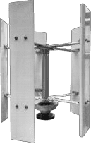
Type H12

Model | H12 -2K | H12 -3K | H12 -5K | H12 -10K |  | H12 -20K |  | H12 -30K | H12 -50K | H12 -100K
Rated power | 2000w | 3000w | 5000w | 10Kw |  | 20Kw |  | 30Kw | 50kw | 100kw
Rated voltage | 48V/96V/120V/220V/380V |  |  | 120V/220V/240V/380V/480V |  |  |  |  | 380V/480V/600V… …
Start the wind speed | 2m/s |  |  | 2.5m/s |  |  |  |  | 3m/s
Rated wind speed | 12m/s |  |  | 11m/s |  |  |  |  | 10m/s
Safe wind speed | ≤50m/s
Blade diameter/height（ m） | 1.55/2.4 | 2/3 | 2.2/4.2 | 3.9/5 |  | 4.65/7 |  | 5.8/10 | 6.65/15 | 9/25
Number of blades | 5
Blade material | Aluminum alloy
Fuselage material | Aluminum alloy |  | cast iron
Magnetic steel material | NdFeB
Generator type | Three -phase AC external rotor generator
Control mode | Electromagnetic brakes
Wind direction adjustment | 360° automatic windward wind
Service life/Degree of protection | ≥ 20 yearsIP54
Net weight（kg） | 150 | 280 | 650 |  | ≈ 1.3t |  | -
Packing size （ m） | 2.5*0.33*0.32+  1.1*0.4*0.48 | 1.5*0.5*0.5+  3.1*0.4*0.4 | 4.25*0.32*0.52  1.3*0.66*0.67+  2.3*0.6*0.6 |  | -

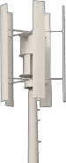

Type H530 plus

Model | H530-400 | H530-500 | H530-600 | H530 -800 | H530 -1000 | H530-1500
Rated power | 400W | 500W | 600W | 800W | 1000W | 1500W
Rated voltage | 12V/24V/48V |  |  |  | 24V/48V/96V
Start the wind speed | 2.5m/s
Rated wind speed | 11m/s
Safe wind speed | ≤50m/s
Blade diameter/height（ m） | 0.95*1.3 | 0.95*1.4 | 1.16*1.6 | 1.16*1.8 | 1.35*2 | 1.67*2.2
Number of blades | 5 high-speed blades+Assist the wind wheel
Blade material | Aluminum alloy
Fuselage material | Aluminum alloy
Magnetic steel material | NdFeB
Generator type | Three -phase AC external rotor generator
Control mode | Electromagnetic brakes
Wind direction adjustment | 360° automatic windward wind
Service life/Degree of protection | ≥ 20 yearsIP54
Net weight（kg）
Packing size（ m） | 1*0.34*0.38+  1.3*0.25*0.3 | 1*0.34*0.38+  1.4*0.25*0.3 | 1.5*0.5*0.6+  1.65*0.3*0.3 | 1.5*0.5*0.6+  1.85*0.3*0.3 | 1.6*0.5*0.5+  2.05*0.31*0.31 | 1.6*0.7*0.81+  2.25*0.32*0.32

Type H530 plus

Model | H530-2000 | H530-3000 | H530-5000 | H530 -10K | H530 -20K | H530-30K
Rated power | 2000W | 3000W | 5000W | 10KW | 20KW | 30KW
Rated voltage | 48V/96V/120V/220V/380V |  |  | 220V/380V/480V… …
Start the wind speed | 2.5m/s
Rated wind speed | 11m/s
Safe wind speed | ≤50m/s
Blade diameter/height（ m） | 2.1/3.2 | 2.63*4.2 | 3.15*5 | 4.25*6.8 | 6.05*9.5 | 7.5*11.5
Number of blades | 5 high-speed blades+Assist the wind wheel
Blade material | Aluminum alloy
Fuselage material | Aluminum alloy |  | cast iron
Magnetic steel material | NdFeB
Generator type | Three -phase AC external rotor generator
Control mode | Electromagnetic brakes
Wind direction adjustment | 360° automatic windward wind
Service life/Degree of protection | ≥ 20 yearsIP54
Net weight（kg） |  |  | 850kg
Packing size（ m） |  |  | 3.25*1*1+  5*0.7*0.8+  1.7*0.6*0.35

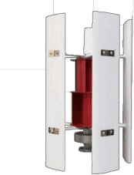
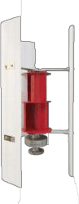

Type HS530 Type HS310

Model | HS-100 | HS-200 | HS-300 | HS-400
Rated power | 100W | 200W | 300W | 400W
Rated voltage | 12V/24V
Start the wind speed | 1.5m/s
Rated wind speed | 12m/s
Safe wind speed | ≤50m/s
Fan blade diameter/height | 0.55m/0.8m
Number of blades | 3/5
Blade material | nylon
Fuselage material | Aluminum alloy
Magnetic steel material | NdFeB
Generator type | Three -phase AC permanent magnet levitation generator
Control mode | Electromagnetic brakes
Wind direction adjustment | 360° automatic windward wind
Service life/Degree of protection | ≥ 20 yearsIP54
Net weight/gross weight | 9.5kg/10.5kg | 10kg/11kg | 10.5kg/11.5kg | 11kg/12kg
Packing size | 86*38*20cm

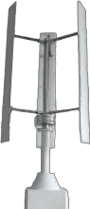

Type HLK33

Model | HLK33 -400 | HLK33 -500 | HLK33 -600 | HLK33 -800 | HLK33 -1000 | HLK33 -1500
Rated power | 400w | 500w | 600w | 800w | 1000w | 1500w
Rated voltage | 12V/24V/48v/96v
Start the wind speed | 2.5m/s
Rated wind speed | 12m/s
Safe wind speed | ≤50m/s
Blade diameter/height（ m） | 0.78*1.3 | 0.78*1.4 | 0.95*1.6 | 0.95*1.8 | 1.16*2 | 1.35*2.2
Number of blades | 3
Blade material | Aluminum alloy
Fuselage material | Aluminum alloy
Magnetic steel material | NdFeB
Generator type | Three -phase AC External rotor generator
Control mode | Electromagnetic brakes
Winddirection adjustment | Automatic windward
Design life | 25 years
Degree of protection | IP54

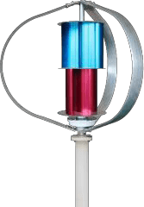
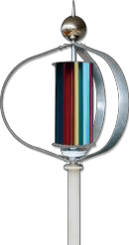

Type Q1 Type Q2

Model | Q1/Q2 -100 | Q1/Q2 -200 | Q1/Q2 -300
Rated power | 100W | 200W | 300W
Rated voltage | 12V/24V
Start the wind speed | 2m/s
Rated wind speed | 12m/s
Safe wind speed | ≤50m/s
Fan blade diameter/height | 1*0.9
Number of blades | 3 high-speed blades+Assist the wind wheel
Blade material | Aluminum alloy
Fuselage material | Aluminum alloy
Magnetic steel material | NdFeB
Generator type | Three -phase AC permanent magnet levitation generator
Control mode | Electromagnetic brakes
Wind direction adjustment | 360° automatic windward wind
Service life/Degree of protection | ≥ 20 yearsIP54
Net weight/gross weight | 16kg/17kg | 16.5kg/17.5kg | 17kg/18kg
Packing size | 910*330*330mm+900*500*100mm

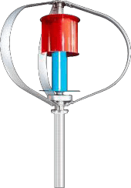
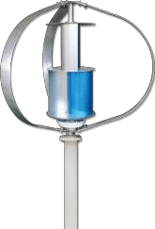

Type Q4max Type Q5max

Model | Q4-400 | Q4-500 | Q5-600 | Q5-800 | Q5-1000
Rated power | 400W | 500W | 600W | 800W | 1000W
Rated voltage | 12V/24V/48V |  | 24V/48V/96V
Start the wind speed | 2m/s
Rated wind speed | 12m/s
Safe wind speed | ≤50m/s
Fan blade diameter/height | 1.15m/1m |  | 1.3m/1.2m |  | 1.6m/1.5m
Number of blades | 3 high-speed blades+Assist the wind wheel
Blade material | Aluminum alloy
Fuselage material | Aluminum alloy
Magnetic steel material | NdFeB
Generator type | Three -phase AC external rotor generator
Control mode | Electromagnetic brakes
Wind direction adjustment | 360° automatic windward wind
Service life/Degree of protection | ≥ 20 yearsIP54
Net weight/gross weight | 26kg/28kg | 28kg/30kg | 40kg/50kg | 45kg/55kg | 85kg/100kg
Packing size | 1.13*0.43*0.43m+0.97*0.12*0.66m |  | 1.22*0.5*0.6m+1.2*0.6*0.1m |  | 1.6*0.7*0.7m+  1.5*0.8*0.1

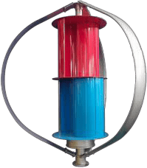

Type Q10max

Model | Q10-1500 | Q10-2000 | Q10-3000 | Q10 -5000
Rated power | 1500W | 2000W | 3000W | 5000W
Rated voltage | 48V/96V/120V/220V/380V
Start the wind speed | 2.5m/s
Rated wind speed | 12m/s
Safe wind speed | ≤50m/s
Fan blade diameter/height | 2m/1.9m | 2.5m/2.4m | 3m/2.9m | 3.6m/3.5m
Number of blades | 3 high-speed blades+Assist the wind wheel
Blade material | Aluminum alloy
Fuselage material | Aluminum alloy
Magnetic steel material | NdFeB
Generator type | Three -phase AC external rotor generator
Control mode | Electromagnetic brakes
Wind direction adjustment | 360° automatic windward wind
Service life/Degree of protection | ≥ 20 yearsIP54
Net weight/gross weight |  | 200kg/270kg
Packing size | 2*0.7*0.7m+  1.5*1*0.15m | 2.4*0.85*0.85m+  2*1.4*0.2m | 3.2*1.03*1.14m+  2.5*1.5*0.25m | 3.8*1.2*1.3m+  3*2*0.3m

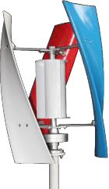
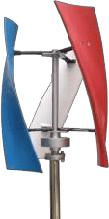

Type X3 Type X3plus

Model | X3-100 | X3-200 | X3-300 | X3 -400
Rated power | 100W | 200W | 300W | 400W
Rated voltage | 12V/24V
Start the wind speed | 2m/s
Rated wind speed | 12m/s
Safe wind speed | ≤50m/s
Fan blade diameter/height | 0.55m/0.75m
Number of blades | 3
Blade material | nylon
Fuselage material | Aluminum alloy
Magnetic steel material | NdFeB
Generator type | Three -phase AC permanent magnet levitation generator
Control mode | Electromagnetic brakes
Wind direction adjustment | 360° automatic windward wind
Service life/Degree of protection | ≥ 20 yearsIP54
Net weight/gross weight | 9kg/10kg | 9.5kg/10.5kg | 10kg/11kg | 11kg/12kg
Packing size | 86*38*20cm

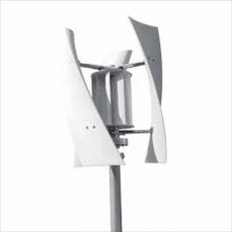
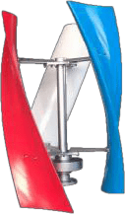

Type X5 Type X5 plus

Model | X5 -400 | X5-500 | X5-600
Rated power | 400W | 500W | 600W
Rated voltage | 12V/24V/48V
Start the wind speed | 2m/s
Rated wind speed | 12m/s
Safe wind speed | ≤50m/s
Fan blade diameter/height | 0.65m/0.9m
Number of blades | 3
Blade material | nylon
Fuselage material | Aluminum alloy
Magnetic steel material | NdFeB
Generator type | Three -phase AC permanent magnet levitation generator
Control mode | Electromagnetic brakes
Wind direction adjustment | 360° automatic windward wind
Service lifeDegree of protection | ≥ 20 yearsIP54
Net weight/gross weight | 20kg/21kg | 21kg/22kg | 22kg/23kg
Packing size | 106*27*49cm

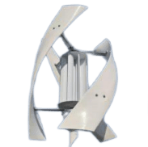

Type X9

Model | X9 -800 | X9-1000 | X9-1500
Rated power | 800W | 1000W | 1500W
Rated voltage | 24V/48V/96V
Start the wind speed | 2m/s
Rated wind speed | 12m/s
Safe wind speed | ≤50m/s
Fan blade diameter/height | 0.8m/1.5m |  | 1.1m/1.65m
Number of blades | 3
Blade material | Reinforced FRP |  | Aluminum alloy
Fuselage material | Aluminum alloy
Magnetic steel material | NdFeB
Generator type | Three -phase AC permanent magnet levitation generator
Control mode | Electromagnetic brakes
Wind direction adjustment | 360° automatic windward wind
Service life/Degree of protection | ≥ 20 yearsIP54
Net weight/gross weight
Packing size | 100*37*41cm+220*30*50cm |  | 100*52*57cm+220*30*50cm

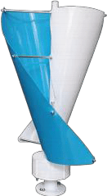

Small spiral type - permanent magnet

Model | SSV-100 | SSV-200
Rated power | 100W | 200W
Rated voltage | 12V/24V
Start the wind speed | 1.5m/s
Rated wind speed | 12m/s
Safe wind speed | ≤50m/s
Fan blade diameter/height | 0.4m/0.7m
Number of blades | 2
Blade material | Aluminum alloy
Fuselage material | Aluminum alloy
Magnetic steel material | NdFeB
Generator type | Three -phase AC permanent magnet generator
控制方式Control mode | Electromagnetic brakes
Wind direction adjustment | 360° automatic windward wind
Service life/Degree of protection | ≥ 20 yearsIP54
Net weight/gross weight | 8kg/9kg | 9kg/10kg
Packing size | 73*22*20cm

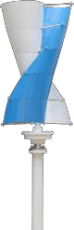
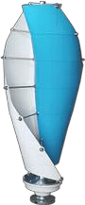

Small spiral type - permanent magnet levitation generator

Model | SV-100 | SV-200 | SV-300
Rated power | 100W | 200W | 300W
Rated voltage | 12V/24V
Start the wind speed | 1.5m/s
Rated wind speed | 12m/s
Safe wind speed | ≤50m/s
Fan blade diameter/height | 0.5m/1m |  | 0.5m/1.15m
Number of blades | 10/2 |  | 12
Blade material | Aluminum alloy
Fuselage material | Aluminum alloy
Magnetic steel material | NdFeB
Generator type | Three -phase AC permanent magnet levitation generator
Control mode | Electromagnetic brakes
Wind direction adjustment | 360° automatic windward wind
Service life/Degree of protection | ≥ 20 yearsIP54
Net weight/gross weight | 13kg/14kg | 14kg/15kg | 16kg/17kg
Packing size | 1000*260*260mm |  | 1200*260*260mm

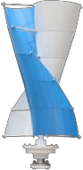

Lager spiral type - ermanent magnet levitation generator

Model | SV-200 | SV-300 | SV-400
Rated power | 200W | 300W | 400W
Rated voltage | 12V/24V
Start the wind speed | 1.5m/s
Rated wind speed | 12m/s
Safe wind speed | ≤50m/s
Fan blade diameter/height | 0.65m/1.25m |  | 0.65m/1.45m
Number of blades | 10 |  | 12
Blade material | Aluminum alloy
Fuselage material | Aluminum alloy
Magnetic steel material | NdFeB
Generator type | Three -phase AC permanent magnet levitation generator
Control mode | Electromagnetic brakes
Wind direction adjustment | 360° automatic windward wind
Service life/Degree of protection | ≥ 20 yearsIP54
Net weight/gross weight | 21kg/22kg | 22kg/23kg | 26kg/27kg
Packing size | 1470*270*270mm |  | 1620*270*270mm

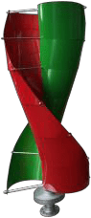
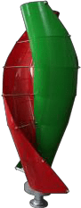

Type V/Lager spiral type - ermanent magnet levitation generator

Model | V-800 | V-1000 | V-1500
Rated power | 800W | 1000W | 1500W
Rated voltage | 24V/48V/96V
Start the wind speed | 2m/s
Rated wind speed | 12m/s
Safe wind speed | ≤50m/s
Fan blade diameter/height | 0.8m/1.85m |  | 0.8m/2.15m
Number of blades | 10 |  | 12
Blade material | Aluminum alloy
Fuselage material | Aluminum alloy
Magnetic steel material | NdFeB
Generator type | Three -phase AC permanent magnet levitation generator
Control mode | Electromagnetic brakes
Wind direction adjustment | 360° automatic windward wind
Service life/Degree of protection | ≥ 20 yearsIP54
Net weight/gross weight | 65kg/75kg | 70kg/80kg | 80kg/90kg
Packing size | 1900*380*320mm |  | 2200*380*320mm

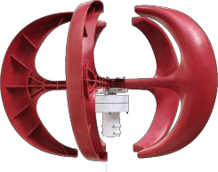
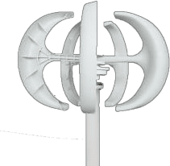

Red Lantern Type White Lantern Type- permanent magnet

Model | R-50 | R-100 | R-200 | R-300
Rated power | 50W | 100W | 200W | 300W
Rated voltage | 12V/24V
Start the wind speed | 1.5m/s
Rated wind speed | 12m/s
Safe wind speed | ≤50m/s
Fan blade diameter/height | 0.9m/0.6m
Number of blades | 5/4
Blade material | nylon
Fuselage material | Aluminum alloy
Magnetic steel material | NdFeB
Generator type | Three -phase AC permanent magnet generator
Control mode | Electromagnetic brakes
Wind direction adjustment | 360° automatic windward wind
Service life/Degree of protection | ≥ 20 yearsIP54
Net weight/gross weight | 9kg/10kg | 9.5kg/10.5kg | 10kg/11kg | 11kg/12kg
Packing size | 61*44*30cm

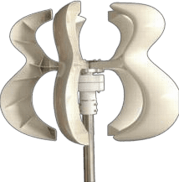
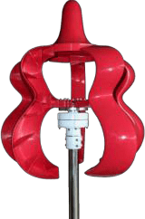

Type HL Type BHL-treasure gourd

Model | HL-50 | HL-100 | HL-200 | HL-300
Rated power | 50W | 100W | 200W | 300W
Rated voltage | 12V/24V
Start the wind speed | 1.5m/s
Rated wind speed | 12m/s
Safe wind speed | ≤50m/s
Fan blade diameter/height | HL=0.8m/0.65mBHL=0.8m/0.85m
Number of blades | 5
Blade material | nylon
Fuselage material | Aluminum alloy
Magnetic steel material | NdFeB
Generator type | Three -phase AC permanent magnet generator
Control mode | Electromagnetic brakes
Wind direction adjustment | 360° automatic windward wind
Service life/Degree of protection | ≥ 20 yearsIP54
Net weight/gross weight | 9kg/10kg | 9.5kg/10.5kg | 10kg/11kg | 11kg/12kg
Packing size | BHL=60*38*38cmHL=60*38*33cm

